ARISE AND SHINE TRIAL 2, TERM 2 2026
Kenya Certificate of Secondary Education
232/3 -
PHYSICS PAPER 3
(Practical)
Time 2 ½ hours

Name ……………………………………………Adm Number………………………

Candidate’s Signature ………………….…..Date …………………………………

Instructions to candidates
- Write your name, index number in the spaces provided above.
- Sign and write the date of examination in the spaces provided above.
- This paper consists of two sections: A and B.
- Answer all the questions in sections A and B in the spaces provided.
- All working must be clearly shown.
- Silent non-programmable electronic calculators may be used.
- Candidates should answer the questions in English.

For Examiners Use Only

Question 1 | a | c | e | f | g | h | Total
Maximum Score | 1 | 1 | 6 | 5 | 4 | 3 | 20
Candidate’s Score

Question 2 | c | g | H | l | M | N | Total
Maximum Score | 1 | 6 | 4 | 5 | 2 | 2 | 20
Candidate’s Score

GRAND TOTAL

Question 1
You are provided with the following;
- Two cells in a cell holder;
- A switch
- A micrometer screw gauge
- A nichrome wire mounted on a millimeter scale
- A voltmeter
- An ammeter
- A jockey
- Connecting wires with crocodile chips

Proceed as follows
- Using the micrometer screw gauge measure and record the diameter d of the wire(1 mark)
d =……………………mm

d = …………………..m

(b). Set up the apparatus as shown in Figure 1
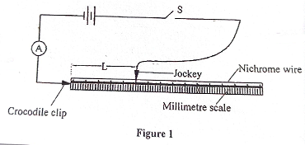
- Using the voltmeter, measure the potential difference E across the battery before closing the switch

- E = ……………..volts (1mark)

Length L (m) | 0.1 | 0.2 | 0.3 | 0.4 | 0.5 | 0.6 | 0.7
Current I (A)
$$\frac{1}{I}A^{-1}$$

(f). On the grid provided; plot her graph of $\frac{1}{I}$ (y-axis) against L (5 marks)
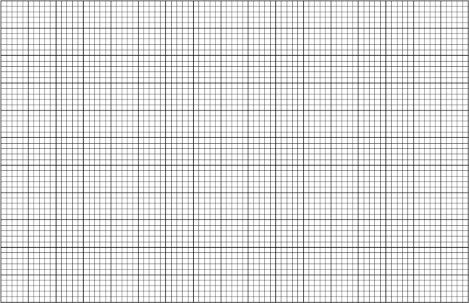

- From the graph; determine the:
- Gradients; (3marks)
…………………………………………………………………………………………………………………………………………………………………………………………………………………………………………………………………………………………………………………….

(ii) Intercept C on the $\frac{1}{I}$ axis (1 mark)
………………………………………………………………………………………………………………………………………………………………………………………………………………

- Given that :
(i) $\frac{{4K}_{1}}{{IId}^{2}E}$ = S determines the value of K₁ (2 marks)
………………………………………………………………………………………………………………………………………………………………………………………………………………
(ii) $\frac{K_{2}}{E}$ = C determines the value of K₂ (1mark)
………………………………………………………………………………………………………………………………………………………………………………………………………………

QUESTION 2

Part A
You are provided with the following:
- A wire
- A glass rod
- A retort stand and a clamp
- A metre rule
- Four 10g masses
- Some cellotape
- Thread 15cm long
- Biconvex lens;
- Some of light (bulb in a bulb holder, cells in a cell holder and a switch;
- A stand, boss and clamp
- A lens holder
- A screen;

5
(a).From one end of the wire meaure 5cm and 7cm from the other end and bend it as shown in Figure 3 below.

5cn free end
7cm free end

(b) Use some sellotape to fix one end of the 5cm along the glass rod; Hold firmly the part of the wire under the tape with one hand. Use the other hand to wind turns as closely and tightly as possible up to the bend of 7cm end. See figure 4 shown below.
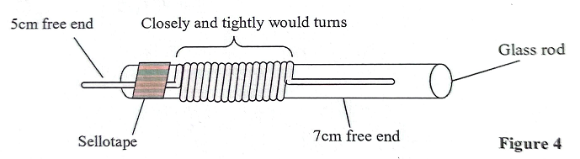
(c). Remove the sellotape and release the spring from the glass rod.

(d). Bend the 5cm free end into a hook and 7cm free end into a hook and a ointer as shown in the fig

(e). Suspend the spring using a 1cm thread and 10g mass alongside a meterrule as shown in the figure 6 below.

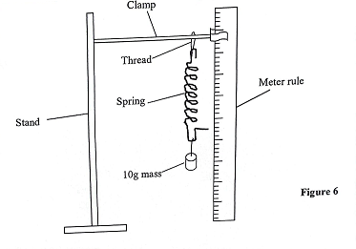
Note the pointer reading on the meter rule and record on the table below. (This will be your initial reading)
Initial reading L_{O} = ………………………cm

(f). Add another 10g mass and again note the pointer reading on the meter rule and record it on the table
(g). Repeat the procedure for the two masses is left. Records the extensions produced each tie and complete table.2

NB: Your initial reading is when only one 10g mass is suspended on the spring

Mass(g) | 10 | 20 | 30 | 40
Loudly (N) on the spring
Pointer reading
Extension(cm)
h =$\frac{L}{e}$
(6 marks)
Table 2
h) Find the average value of h for 20g, 30g and 40g. (2 marks)
………………………………………………………………………………………………………………………………………………………………………………………………………………………………………………………………………………………………………………………
(i). State the quantity represented by h and give it units. (2 marks) ……………………………………………………………………………………………………
…………………………………………………………………………………………………….. …….………………………………………………………………………………………………

PART B
(j). Clamp the bulb holder onto the stand. Arrange the bulb, the lens and the screen along the metre rule as shown.
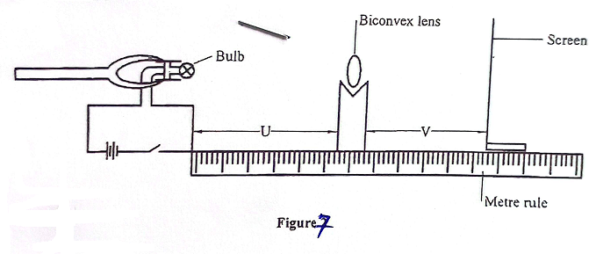
(k). Adjust the distance of the bulb from the lens to U=25cm. Put on the switch and adjust the position of the screen from the lens so that a sharp image of the bulb is observed. Record the distance V between the screen and the lens in Table.

(l) Repeat part (b) for the other values of U shown in table. Complete the t able. (7 marks)
U cm | 25 | 30 | 35
V cm
M = $\frac{V}{U}$
F = $\frac{V}{M+1}$
(m) Determine the average value of F. (2 marks)
………………………………………………………………………………………………………………………………………………………………………………………………………………………………………………………………………………………………………………………………………………………………………………………………………………………………
(n) Given that y =$\frac{1}{F}$;
(i) determine the value of y. ( 1 mark)
………………………………………………………………………………………………………………………………………………………………………………………………………………
(i) What does quantity y represent? (1 mark)
………………………………………………………………………………………………………………………………………………………………………………………………………………

